Call for Help Action Plan
This plan will help you know when to call your doctor or nurse (when you are in the Yellow Zone) to prevent you from going into the Red Zone. Please share this with your care partners.
Name: Emergency Contact:
Primary Care Physician: Phone:
Specialist: Specialist:

Problem | Yellow Zone  Call your doctor or nurse specialist. State the reason you are calling or go to urgent care | Red Zone  Call 911 or go to the Emergency Room (ER)
Infection & Sepsis | - Hard to breathe or more difficult than usual  - Fever of 100°F - 101.4°F or cold/shivering  - Body aches or pain  - Too tired to do any activity  - Infection symptoms are included in other sections below | - Fast breathing and/or cannot catch breath  - Fast heart rate or chest pain  - Temperature 101.5°F or above, OR 96.8°F or below (with other symptoms in this section)  - Drop in blood pressure, light-headed, fainting  - Confused, unable to think clearly, tired  - Skin becomes warm and flushed  - Less pee/urine output, prolonged vomiting, or diarrhea (could indicate dehydration) | TIME  T- Temperature: Higher or lower than normal  I- Infection: May have signs and symptoms of an infection  M- Mental Decline: Confused, sleepy, difficult to rouse  E- Extremely Ill: Severe pain, discomfort, shortness of breath
Lungs:  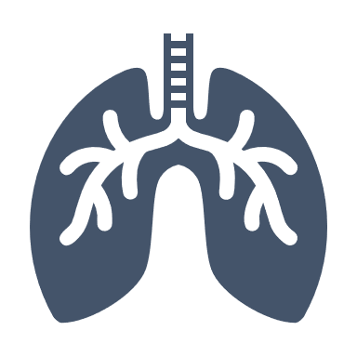  Pneumonia, COPD, Asthma | - Short of breath or wheezing  - Cough that gets worse  - Change in mucus sputum/phlegm): color (yellow, green, bloody), thicker, has odor or increased amount  - Restless, agitated, nervous, shaky  - Fever over 101°F for 24 hours, chills  - Chest pain when breathing | - Hard to breathe, coughing or wheezing that does not respond to medications, inhalers or breathing treatments  - Fast or irregular/abnormal heart rate  - Blue-to-gray colored lips, face, skin, or nails  - Coughing up blood  - Sudden squeezing of chest with pain  - Confusion and agitation
Urinary | - Need to urinate/pee often or only in small amounts  - Pain and burning when urinating/ peeing  - Bloody, cloudy, change in pee/urine color, smells bad  - Fever greater than 100°F for 24 hours with or without antibiotics | - Confused, unable to think clearly  - Nausea, vomiting  - Fever greater than 100.5°F/101°F degrees or chills, shaking or night sweats (with other symptoms in this section)  - Back pain under your ribs or side pain  - Bloody pee/urine  - Unable to urinate/pee
Wound/  Skin Care | - Swelling, tender and an area of the skin that feels cooler or warmer to the touch  - Change in drainage or wound size, color (green, yellow, or bloody) or drainage smells bad  - Increase in pain at wound or injection/infusion (IV) site  - Increase in redness/warmth at wound site  - May have fever greater than 100.5°F degrees/chills  - Wound getting larger or deeper, more swelling | - Severe pain in wound or injection/infusion (IV) site, red, warm, smells or oozing pus or drainage  - Red streaks extending away from the wound  - Signs of worsening infection, such as fever greater than 101.5°F, chills, after being on an antibiotic longer than 48 hours  - Vomiting and diarrhea  - Sepsis: fever-high or low, short of breath, fast heart rate, or confusion or disorientation, and weakness, drop in blood pressure (see Infection & Sepsis section; page 1)  - Large amounts of bleeding
Blood Pressure | - Repeated high blood pressure readings above: 130/80  - You can have high blood pressure, but have no symptoms  - Symptoms may include headache, nosebleed, blurred vision, ringing in ears, lightheaded, heart palpitations (flutter), facial flushing, or blood spots in eyes | - Severe headache or nosebleed  - Lightheaded or dizzy  - Change in memory or confusion  - Heart beating fast or racing  - Pounding in your chest, neck, or ears  - Trouble seeing, talking, or walking | BE FAST  B – Balance Loss  E – Eyesight change  F – Facial Drooping  A – Arm Weakness  S – Speech Difficulty  T- Time to Call 911
Chest Pain - Coronary Artery Disease | - A single episode of chest pain or tightness that goes away within a minute of rest  - Increase in chest pain episodes requiring the use of prescribed Nitroglycerin  - Pain/discomfort in neck, jaw, back, one or both arms, or stomach  - Blood pressure is high  - Heartbeat or rate does not feel normal  - Short of breath, weak or dizzy  - Indigestion | - Chest pain, pressure, or tightness that medication (Nitroglycerin) does not help OR chest pain that goes away and comes back  - Chest discomfort with shortness of breath, sweating or nausea/vomiting that does not resolve within 1-2 minutes of rest
Diabetes | HIGH blood sugar symptoms:  Increased thirst, frequent urination/need to pee, increased hunger, blurred vision, weakness, itchy skin, irritability  - Repeated blood sugars, greater than 200 mg/dL for more than 3 days | - Nausea and vomiting, shortness of breath, fruity breath  - Blood sugar greater than 450 mg/dL  - If family, friends cannot wake you from sleep
 | LOW blood sugar symptoms:  Shakiness, sweating, hunger, headache, fast heartbeat, confusion, changes in vision, irritability  - If experiencing the above symptoms, first test blood sugar (if possible), then treat with a form of sugar, such as three glucose tablets, 4 ounces of juice  - Wait 15 minutes and re-check blood sugar, if your blood sugar is still low (70 or below) and symptoms do not go away, then repeat the treatment and wait another 15 minutes and recheck blood sugar, If your blood sugar is still less than 70, call your doctor  - If your blood sugar returns to your normal range, eat a light snack, such as half of peanut butter or meat sandwich and half a glass of milk | - Unconscious  - Unable to treat low blood sugar at home  - Seizures  - Low blood sugar not responding to treatment  - If family, friends cannot wake you from sleep
Mental or Behavioral Health | - Depressed, nervous, anxious, upset  - Suicidal (and have a “crisis safety plan” in place)  - Stopped taking medications  - Missed mental health appointments  National Suicide Prevention Lifeline: 988 | - You are having thoughts of harming yourself or others  - You have done something to harm yourself or others  National Suicide Prevention Lifeline: 988
Drug or Alcohol Abuse/  Disorder  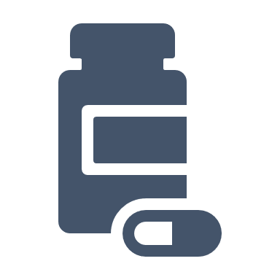 | - Buying or trading drugs from friends, family or on the street  - Withdrawal signs:  - Shaky (tremors)  - Chills or sweating  - Flu-like symptoms  - Nausea, vomiting, diarrhea, stomach cramps  - Trouble sleeping, mind racing  - Fast heartbeat or rate, trouble breathing  - Tolerance: Need more to get same effect  - Dependence: Body needs substance to feel and function normally | - Severe withdrawal signs – may need detox  - Severe depression or unstable mood  - Feel out of control when taking the substance  - Crave the drug (medicine) after completing prescription  - Continue to use substance even when it has had a negative effect on physical and/or mental health  Signs of Substance Use Disorder – seek help 24/7  SAMHSA’s National Helpline:  1-800-662-HELP (4357)

Disclaimer: This list does not include all possible symptoms.
Please call your doctor if you have any other symptoms that are severe or concern you.

This material was prepared by Great Plains Quality Innovation Network, a Quality Innovation Network – Quality Improvement Organization, under contract with the Centers for Medicare & Medicaid Services (CMS), an agency of the U.S. Department of Health and Human Services (HHS). Views expressed in this material do not necessarily reflect the official views or policy of CMS or HHS, and any reference to a specific product or entity herein does not constitute endorsement of that product or entity by CMS or HHS. 12SOW/GPQIN/QIN-QIO-277/0323

