I would like you to meet . . .James, age 78, who lives at home with Martha, his wife of 48 years. He was admitted to the hospital with shortness of breath.

Heart Failure Definition¹
An acute or chronic inability of the heart to maintain adequate blood circulation to the peripheral tissues and the lungs, usually characterized by fatigue, edema, and shortness of breath. It has many causes, including coronary artery disease, hypertension and cardiomyopathy. It is also called congestive heart failure.

1The American Heritage® Science Dictionary Copyright © 2005 by Houghton Mifflin Company. Published by Houghton Mifflin Company.

Medical Terminology | Plain Language
Acute
Chronic
Peripheral tissues
Fatigue
Edema
Hypertension
Cardiomyopathy
Heart failure

Resource: Plain Language Medical Dictionary University of Michigan

- 1

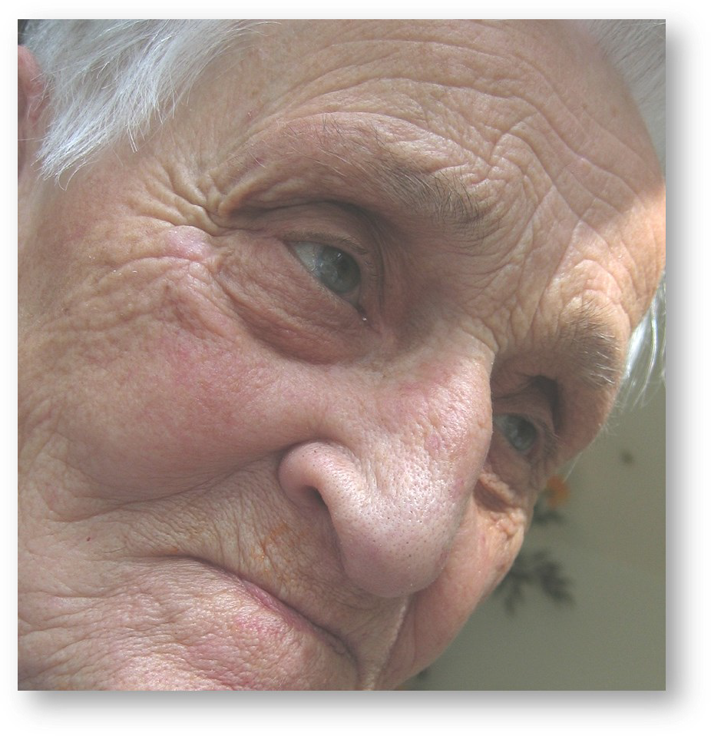
I would like you to meet . . .Henry, age 85, has lived at your facility since his wife died several years ago. His condition has deteriorated over the past several months. It is time for ‘the conversation’.

Health Care Directive² (advance directive)
A legal document (as a living will) signed by a competent person to provide guidance for medical and healthcare decisions (as the termination of life support or organ donation) in the event the person becomes incompetent to make such decisions.

2The American Heritage® Science Dictionary Copyright © 2005 by Houghton Mifflin Company. Published by Houghton Mifflin Company.

Medical Terminology | Plain Language
Deteriorate
Competent
Guidance
Cardiovascular resuscitation
Termination
Life support
Incompetent
Healthcare directive

Resource: Plain Language Medical Dictionary University of Michigan

This material was prepared by Great Plains Quality Innovation Network, a Quality Innovation Network – Quality Improvement Organization, under contract with the Centers for Medicare & Medicaid Services (CMS), an agency of the U.S. Department of Health and Human Services (HHS). Views expressed in this material do not necessarily reflect the official views or policy of CMS or HHS, and any reference to a specific product or entity herein does not constitute endorsement of that product or entity by CMS or HHS. 12SOW/GPQIN/QIN-QIO-237/1022
- 2

