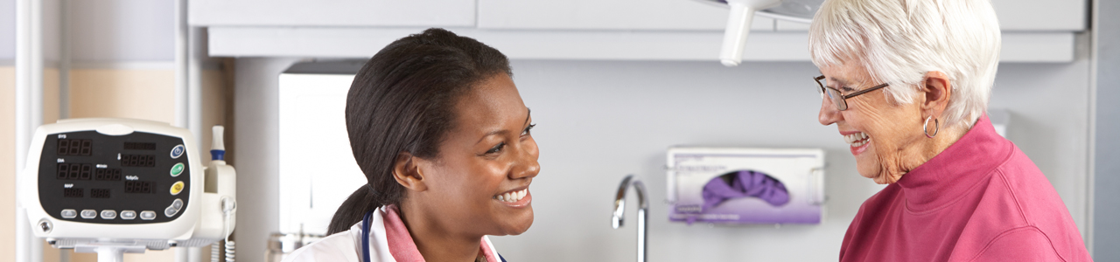
TEACH-BACK IS…

- A way to make sure YOU - the Healthcare Provider – explained information clearly; it is NOT a quiz to test the patient

- Asking the patient (or family member) to explain – in their own words – what they need to know or do - in a caring way

- A research-based health literacy intervention that promotes adherence, quality and patient safety

- A way to check for understanding and, if needed, an opportunity to re-explain and check again

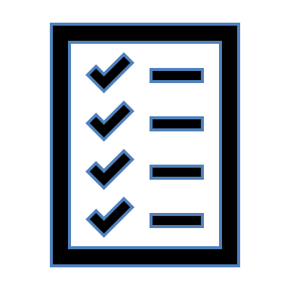
Only 12 percent of adults in the United States have a high level of health literacy. In other words, nearly nine out of 10 adults lack the skills needed to fully manage their health care and prevent disease. [National Assessment of Adult Literacy]

In addition, 40 – 80% of medical information is forgotten immediately. [Health Literacy Universal Precautions Toolkit]

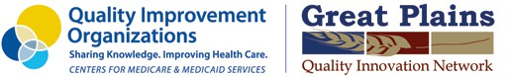

This material was prepared by Great Plains Quality Innovation Network, a Quality Innovation Network – Quality Improvement Organization, under contract with the Centers for Medicare & Medicaid Services (CMS), an agency of the U.S. Department of Health and Human Services (HHS). Views expressed in this material do not necessarily reflect the official views or policy of CMS or HHS, and any reference to a specific product or entity herein does not constitute endorsement of that product or entity by CMS or HHS. 12SOW/GPQIN/QIN-QIO-234/1022

