Staircase in the Dark: Kathy Otten’s Fall Story
Fall prevention is often associated with the elderly. I want others to know, that is not always the case. In July 2019, I returned from a wonderful vacation to Colorado with my family. Two days later, I found myself in a very different situation.
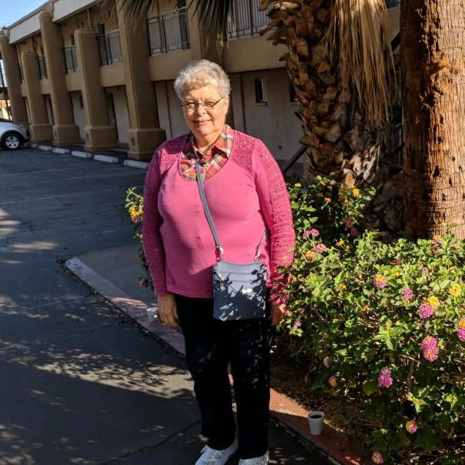
I remember getting up in the middle of the night to put some Lipton Iced Tea in the refrigerator for my husband to take to work the next day. I have gone through my living room to the kitchen in the dark hundreds of times before. This time was different. On my way back to the bedroom, I reached for the corner, not realizing I was at the top of my basement stairway. I remember feeling the open space and then the falling began.
I fell head-first down a flight of 15 steps to the basement. I remember feeling the thud on my head and hitting against the railing on my left side. Nothing could stop me. When I reached the bottom, I was conscious, and I knew I was hurt. My left side and my back hurt, and I couldn’t get out of the contorted position I was in. I yelled to my husband for help and worried that he would never hear me. He uses a C-Pap and takes his hearing aids out at night, so he is the next thing to deaf.
By a miracle that only God could have made, he heard me and came to my rescue. He wondered if I was able to move and so did I. I am a 64-year old retired nurse. I knew if I couldn’t move my feet, I could be paralyzed. Being on a blood thinner, I also recognized the risk of a severe head bleed. We both realized I was not going anywhere, and my husband immediately called 911.
I was still conscious and remember the first person to arrive was the police. Shortly after, the fire and rescue department and the ambulance arrived. They were able to come down a different set of stairs from our garage and help me onto the stretcher. I remember them starting an IV to give me pain medicine, and then I must have drifted off. When I arrived at the hospital, they began asking my husband all sorts of questions. I was able to answer some of them. Then they took me off for X-rays, CT scan and did lab work.
It was determined I had fractured my left clavicle (collar bone) and four ribs. Fortunately, I didn’t have a head bleed. I ended up staying in the hospital for a day until I could get my pain under control, and we could make a plan for how I was going to function at home alone. My husband had to get me a shower chair because I needed to have something safe to sit on. It was several weeks before I was able to get back to doing some of my regular activities and several months before the majority of my pain left.
I was so grateful to God for watching over me and sending His angels that night. I was also grateful to the excellent caregivers from Tea police, fire and rescue and Sanford Hospital for coming to my rescue. I am grateful that my husband was awakened by some angels that night to hear my cry for help.
I am writing this to let you know how important it is to have nightlights in your hallways to light your path. By this simple effort, my fall could have been prevented. I have them in my hall now, and I am not afraid to turn on the lights at night! Be smart and be safe!!

